**Visvesvaraya Technological University**

# Belagavi, Karnataka, 590 014.



## AICTE Activity Point Programme on

**“Doubling The Income Of** **Village By** **Health Care And Education”**

(Non-Credit Activity of 2 Weeks (80-90 hours))

Submitted in partial fulfillment of the requirements for the award of

**Bachelor of Engineering**

**in**

**Computer Science and Engineering**

**Semester IV**

**Academic Year 2022-2023**

***Department of Computer Science & Engineering***

|  |  |  |
| --- | --- | --- |
|  | K. L. E. SOCIETY’SK. L. E. INSTITUTE OF TECHNOLOGY,Opp. Airport, Gokul, Hubballi-580 030Phone: 0836-2232681 Website: www.kleit.ac.in | **kle-logo** |

## AICTE Activity Point Programme on

**“Doubling The Income Of** **Village By** **Health Care And Education”**

**Team Members**

* 2KE20CS006 Ananya V Melupparagimath
* 2KE20CS016 Banashankari N Kammar
* 2KE20CS024 Gayatri Gopal Gudi
* 2KE20CS038 Krutika R Soraganvi
* 2KE20CS058 Pranjali S Patil
* 2KE20CS071 Rashmi K Biradar
* 2KE20CS072 Rohini Girish Navade
* 2KE20CS080 Sanjana R Deshpande
* 2KE20CS081 Sanjana Sampat Kadapatti

**DOUBLING THE INCOME OF** **VILLAGE BY**

**HEALTH CARE AND EDUCATION**

**1.1  INTRODUCTION:-**

In medicine, rural health or rural medicine is the interdisciplinary study of health and health care delivery in rural environments. The concept of rural health incorporates many fields, including geography, midwifery, nursing, sociology, economics, and telehealth or telemedicine.

                      Research shows that the healthcare needs of individuals living in rural areas are different from those in urban areas, and rural areas often suffer from a lack of access to healthcare. These differences are the result of geographic, demographic, [socioeconomic](https://en.wikipedia.org/wiki/Socioeconomic), workplace, and personal health factors. For example, many rural communities have a large proportion of elderly people and children. With relatively few people of working age (20–50 years of age), such communities have a high [dependency ratio](https://en.wikipedia.org/wiki/Dependency_ratio). People living in rural areas also tend to have poorer socioeconomic conditions, less education,

higher rates of tobacco and alcohol use, and higher [mortality rates](https://en.wikipedia.org/wiki/Mortality_rates) when compared to their urban counterparts. There are also high rates of poverty among rural dwellers in many parts of the world, and poverty is one of the biggest [social determinants of health](https://en.wikipedia.org/wiki/Social_determinants_of_health_in_poverty).

**1.2 LITERATURE SURVEY**:-

Rural communities and healthcare facilities have limited resources to address many health-related needs. Research and needs assessments can help determine where and how resources may best be targeted, and program evaluations can indicate whether a particular intervention or approach works well in a rural context.

Rural stakeholders who understand the purposes of conducting research, needs assessments, and program evaluations, and who have the tools to undertake such activities, will be better positioned to focus their efforts where they will have the best result. Likewise, policymakers and funders who understand how to help rural communities by supporting rural health research, assessments, and evaluations can help build our nation's understanding of rural health needs and effective interventions to address those needs.

Given the importance of research, assessment, and evaluation to rural interventions and policy, the best rural health research and community assessments have a member of the community as a member of the research team helping to ensure that confidentiality is maintained, programs are appropriate, and language is accurate and reflects the culture of the community.

Ideally, residents should be able to conveniently and confidently access services such as primary care, dental care, Behavioral health, emergency care, and public health services. According to [Healthy People 2020](https://www.healthypeople.gov/2020/leading-health-indicators/2020-lhi-topics/Access-to-Health-Services), access to healthcare is important for:

· Overall physical, social, and mental health status

· Disease prevention

· Detection, diagnosis, and treatment of illness

· Quality of life

· Avoiding preventable deaths

· Life expectancy

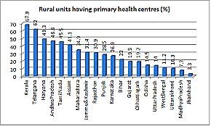

1.3 **Challenges for Rural Health System –**

                            An Overview The poor state of the health system in rural areas is not the outcome of a particular occurrence but a consolidated outgrowth of degraded system. It signifies not only lacunae in existing policy and infrastructure but blockage in potential development also. The expenditure on public health has not only been ignored by the state but by common man also. The Common man terms expenditure on public health as useless. In their view, the quality of treatment and medicines in government-run hospitals has degraded. Their diverted investment in private practitioner and private hospitals has worsened public health system in India. The disillusionment and frustration with the growing ineffectiveness of the government sector is gradually driving poor people to seek help of the private sector, thus forcing them to spend huge sums of money on credit, or they are left to the mercy of ‘quacks’. Therefore, it is very essential for us to review primary elements for degradation of Public health system in India.

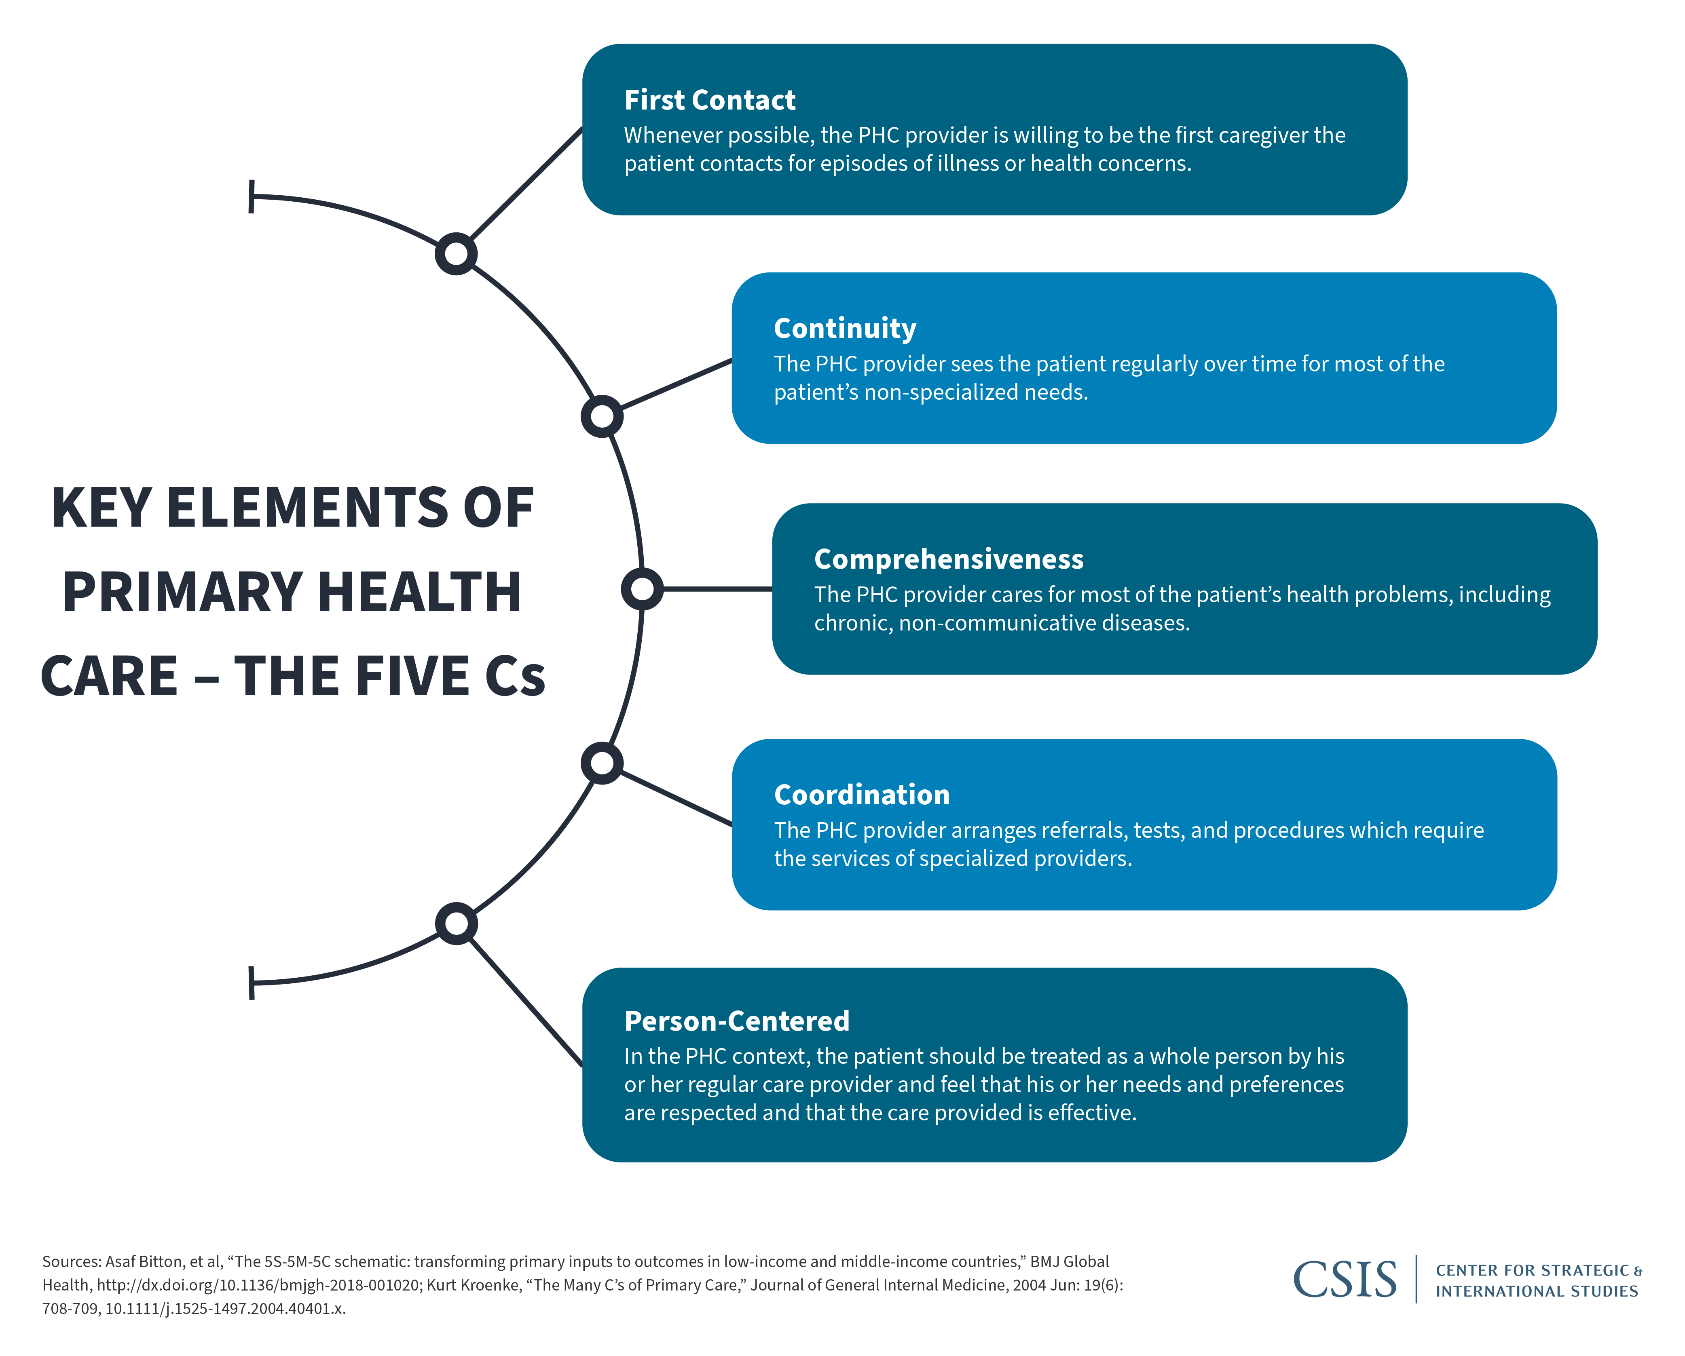

**1.3.1  Inefficient Physical Infrastructure:**

The sub-centre (SC) is the most peripheral institution or first contact point between Primary Health Centre (PHC) and community. Each sub-centre is manned by one Auxiliary Nursing Mid-wife (ANM) and one Multi-Purpose Worker (MPW). The sub-centres are needed for taking care of basic health needs of men, women and children. Apart from it, PHC also keeps an important position in health services. It provides integrated curative and preventive healthcare to the rural population with an emphasis on preventive and promotive aspects. At upper level, remains CHC. The major function of CHC is to provide comprehensive coverage of health care to patients referred from PHC. In this affair, poor infrastructure of the hospitals is a matter of serious concern.

**1.3.2**  **Underutilization of existing rural hospitals:-**

              On one hand, there is lackness of efficient health infrastructure in rural areas, on the other hand, these infrastructure are not being utilized by people. Many a time, rural patients bypass local rural hospitals despite the availability of comparable medical services. The general conditional analysis of data on patients and hospitals suggests that hospital characteristics (size, ownership, and distance) and patient characteristics (payment source, medical condition, age, and race) influence rural patients’ decisions to bypass local rural hospitals.

**1.3.3  Inadequate human resources:-**

The rural public health facilities are battling with the problems of inadequate manpower. There exists shortfall across all cadres in rural health system. The deficiency of trained doctors and medical professionals has paralyzed the rural health facilities. As of March’ 2013, the vacancy rates of doctors at PHCs has been 12 percent while the same at CHCs has been 47 percent at India level (NRHM, Budget Briefs, 2014-15).

**The State of Healthcare in Rural Communities:-**

The statistics tell the story: By several important health metrics, people who live in rural areas have higher mortality rates and worse health than their urban counterparts. For example:

**Overall mortality:** Although mortality rates have dropped for both urban and rural areas, they are still far higher in rural areas, according to this pre-COVID 19 study in the Journal of the American Medical Association. In 2019, urban areas had a mortality rate of 664.5 per 100,000 people; rural areas had a mortality rate of 834 per 100,000 people.

**COVID-19:** As of December 2021, the case rate and mortality rate from the coronavirus was higher in rural counties than in urban counties — 287.55 deaths per 100,000 in rural areas compared to 221.54 per 100,000 in cities and towns, according to the Rural Policy Research Institute.

**Diabetes:** Diabetes is more prevalent in rural areas than in urban areas. Rural patients are less likely to comply with checkups and preventive treatments and showed less improvement in their disease than urban patients, according to the journal Diabetes Care.

**Heart disease:** Heart disease-related deaths were higher in rural areas compared to urban areas — 160 per 100,000 people compared to 114.5 per 100,000, according to the CDC.

**Opioid overdoses:** While urban areas saw higher overdose rates in general, rural areas saw higher rates of opioid overdoses, especially among women, the CDC reports.

**Suicide:** The suicide rate in rural communities is 20.1 per 100,000 — twice as high as for large cities, according to CDC research.

**Approaches:**

### Full Practice Authority for Nurse Practitioners

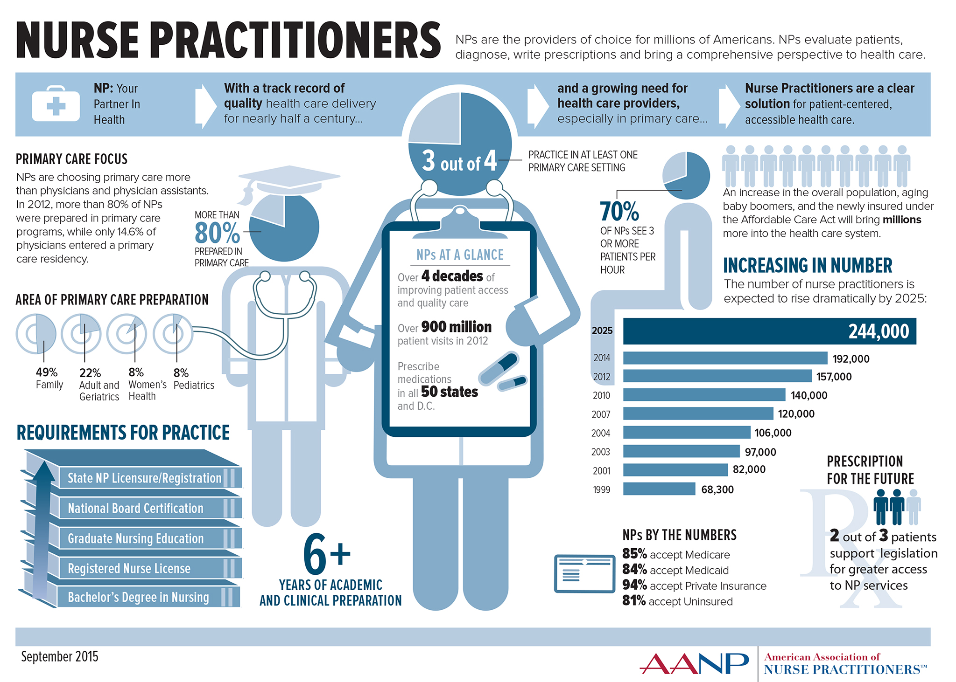

Some two dozen states allow nurse practitioners to have [full practice authority](https://www.aanp.org/advocacy/advocacy-resource/policy-briefs/issues-full-practice-brief), meaning they can see patients, prescribe medications, and order tests without being overseen by a physician. Nurse practitioners are more likely to work in underserved areas, in hospitals, clinics, and private practice. They provide healthcare at a cost savings compared to physicians. Some health experts see nurse practitioners as part of the solution to the shortage of healthcare providers in rural areas.

### Telemedicine

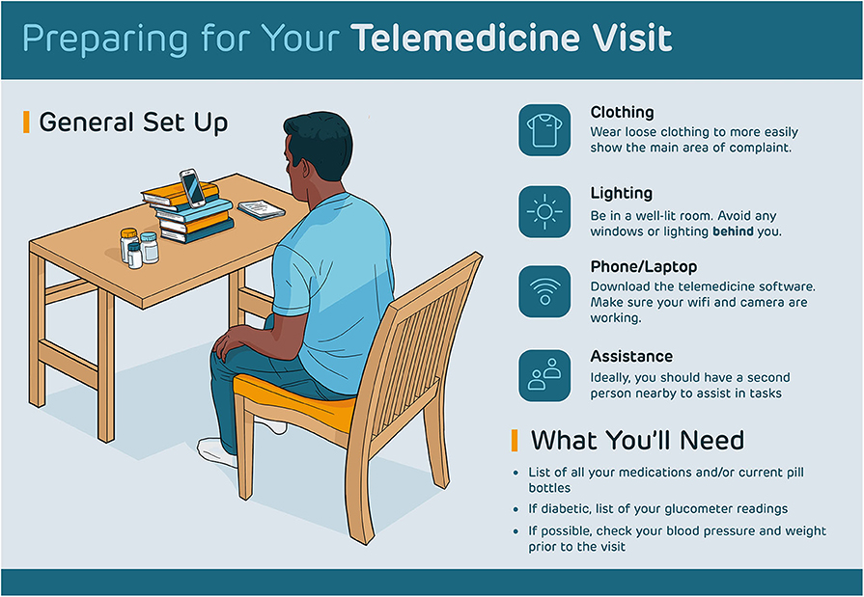

[Rural communities could benefit from telemedicine](https://www.usnews.com/news/national-news/articles/2021-06-23/addressing-disparities-in-rural-health-care), which solves the problem of rural patients having to drive long distances to see a doctor. During the COVID-19 pandemic, telemedicine allowed doctors to continue to see patients without risk of infection.

Telemedicine has traditionally been a cost savings compared to in-person doctor visits. However, the cost savings are no longer as dramatic since doctors have been cleared to charge their full fee for a telemedicine consultation. Another issue is internet access, which is not always reliable in rural areas.

### 3.Physician Incentives

Rural communities have been creative in coming up with [incentives to bring physicians](https://blog.finder.doximity.info/rural-bound-persuading-doctors-to-work-in-rural-america) to small towns and remote regions. According to the New England Journal of Medicine[, rural doctors are paid 5% to 10% more](https://resources.nejmcareercenter.org/article/demystifying-urban-versus-rural-physician-compensation/) than their urban counterparts. Signing bonuses (in some cases $100,000 or more), relocation allowances, and education loan forgiveness are just some of the other financial perks.

### Federal Government Loan Forgiveness

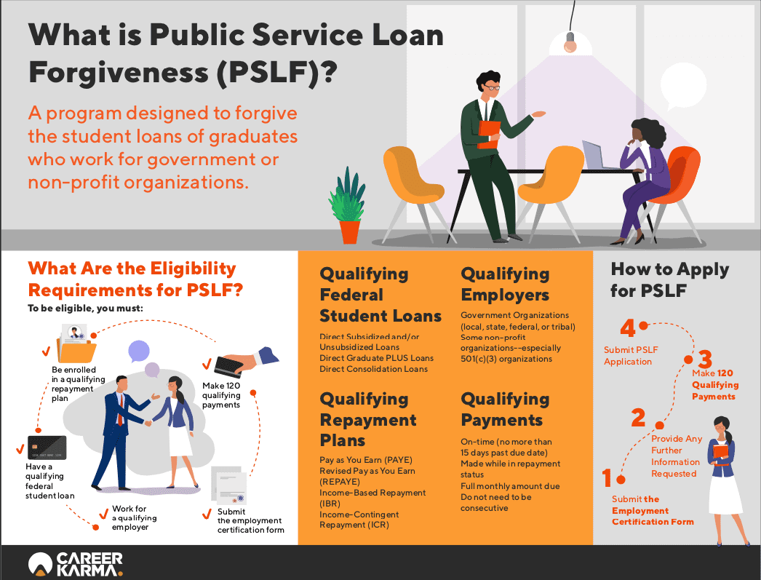

The National Health Services Corp Rural Community Loan Repayment Program will reimburse [education loans for qualified healthcare providers](https://nhsc.hrsa.gov/loan-repayment/nhsc-rural-community-loan-repayment-program) who practice in rural communities. The goal of the program is to bring in doctors, nurses, and other clinicians to treat rural patients with opioid abuse disorder.

### 5.Public-Private Partnerships

[A public-private partnership in Oklahoma](https://journalrecord.com/2019/06/11/bisbee-public-private-partnerships-bring-physicians-to-rural-oklahoma/) funded by the state’s Tobacco Settlement Endowment Trust is offering up to $16,000 in medical school loan repayment assistance to doctors who practice in underserved areas. The goal of the initiative is to help patients quit smoking and improve their overall health.

### 6.Improving Health Literacy

Improving [health literacy may have a positive impact](https://www.trapollo.com/improve-health-literacy-patient-outcomes-telehealth/) on rural populations. Health literacy includes the ability to understand the doctor’s advice and treatment plans. It also includes understanding how to navigate the healthcare system, from making an appointment to getting reimbursed by a health insurer. It can help patients comply with medical advice and prescriptions. Experts believe that improving health literacy can improve the health of rural populations.

### 7.Value-Based Care

Moving from a fee-for-service model to [value-based care may help improve overall healthcare](https://nihcm.org/publications/improving-health-care-outcomes-supporting-providers-in-value-based-care) in rural populations and help hospitals remain financially stable. Value-based care ties payment to patient outcomes.

Medicare’s [hospital readmissions reduction program](https://www.cms.gov/Medicare/Quality-Initiatives-Patient-Assessment-Instruments/Value-Based-Programs/HRRP/Hospital-Readmission-Reduction-Program) is an example of value-based care. Hospitals that reduce readmissions through better procedures and care coordination are rewarded with incentive payments. Value-based care has long been linked to lower cost care and better population health.

### 8.Loosening Regulations

Hospital executives say that [loosening regulations will help rural hospitals](https://www.healthcaredive.com/news/rural-hospitals-in-dire-need-of-regulatory-relief/528403/) become profitable. Industry researchers say that some Medicare regulations, such as how long a patient can stay in the hospital, are too restrictive.

Some experts advocate changes, such as allowing rural regions to repurpose large critical-access hospitals so they can be used as [small emergency centers](https://bipartisanpolicy.org/report/reinventing-rural-health-care/) or outpatient care centers, depending on need. Other issues include determining how providers should be paid for their services, how to communicate with patients, and how long patients should stay in the hospital.

**Remedies in Rural Health System:-**

There have been several strategies and missions initiated

for improvement in rural health scenario. The Government

has taken various steps for institutionalizing the existing

rural health framework.

1. **National Rural Health Mission (NRHM)**

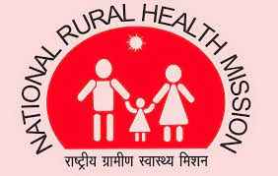

One of key achievements in the area of rural health is National Rural Health Mission (NRHM). It was started in 2005 with an aim to address infirmities and problems across primary health care and bring about improvement in the health system and the health status of those who live in the rural areas. It provides accessible, affordable, effective, accountable, and reliable healthcare to all citizens and in particular to the poorer and vulnerable sections of the population, consistent with the outcomes envisioned in the Millennium Development Goals and general principles laid down in the national and state health policies. NRHM is a flagship scheme of central government to improve the provision of basic healthcare facilities in rural India by undertaking an architectural correction in the existing healthcare delivery system and by promoting good health through improvements in nutrition, sanitation, hygiene and safe drinking water. Under the NHRM, some steps have been taken for the transformation of rural health infrastructure so that degraded conditions of infrastructure may be improved. Through NRHM, the unit level health care centres like PHC, SC have been strengthened. Various PHCs have been transformed into 24X7 PHCs with proper medical facilities.

1. **Janani Suraksha Yojana (JSY)**

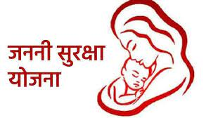

Janani Suraksha Yojana is a flagship programme of Government of India under NRHM which is intended to promote institutional delivery to reduce maternal and neo-natal mortality. It provides cash incentives for women to deliver in a government or accredited private medical facility (India Rural Development Report, 2012/13). Under JSY, the ASHA workers increase cases of institutional deliveries through escorting pregnant women, proper medical facilities for ante-natal care. They work as interface between rural health system and community.

1. **Health Insurance through Rashtriya Swasthya Bima Yojana (RSBY)**

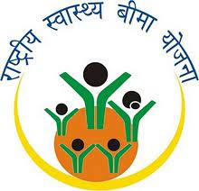

Rashtriya Swasthya Bima Yojana (RSBY) is one of landmark schemes in the area of Rural Health. The RSBY offers a micro-insurance product for households designated as “below the poverty line (BPL)” and aims to cover up to 60 million households throughout the country over the next five years (2008-2013) (Das, Jishnu and Jessica Leino, 2011). The objectives of the RSBY are to provide financial protection for households affected by major health shocks and improve health outcomes for poor households (Das, Jishnu and Jessica Leino, 2011). It was launched in 2008. RSBY insures BPL families for hospitalisation costs and allows them to choose between public and private hospitals. Beneficiaries must pay a nominal registration fee while the cost of premium payments is shared by the central and state governments (Sethi, Sonam, n.d).

First, insurance companies are selected by competitive bidding in each district and receive a premium for every household enrolled by them in the scheme (Das, Jishnu and Jessica Leino, 2011).

Secondly, insurance companies empanel in-patient care facilities (ICFs), they then reimburse ICFs for in-patient care provided to enrolled households. ICFs may be either public or private, public facilities may retain payments from the RSBY in self-governed societies known as Rogi Kalyan Samitis (Das, Jishnu and Jessica Leino, 2011).

Thirdly, eligible households (those identified as BPL by their states) can enrol in the programme by paying Rs. 30, in return for which they receive a smart card. A maximum of five members may enrol from any family, including the head, spouse and up to three dependents of the head of the household (Das, Jishnu and Jessica Leino, 2011). As of March’ 2014, the RSBY has been rolled out in over 436 dis-tricts in 29 states and covered around 37 million BPL families .

1. **Mobile-based Primary Health Care System**

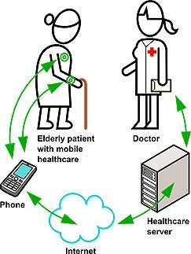

The Mobile-based Primary Health Care System is having crucial role in the area of rural health. Primary health care services based on mobile devices ensures improved access to primary healthcare (Murthy, M.V Ramana, n.d). This system of mobile healthcare which was initiated in 2005, uses a mobile phone to transmit a person’s vital signs. The health professionals may be able to remotely monitor patients suffering from chronic diseases across the country. This implies offering a wide range of services such as health education, promotion of nutrition, basic sanitation, the provision of mother and child family welfare services, immunisation, disease control and appropriate treatment for illness and injury

1. **Indira Gandhi Matritva Sahyog Yojana**

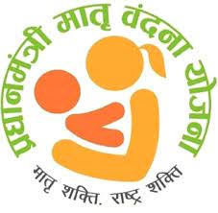

Indira Gandhi Matritva Sahyog Yojana (IGMSY) was started in 2010 with a purpose of encouraging women to follow Infant and Young Child Feeding (IYCF) practices including early and exclusive breast feeding for first six months. IGMSY is a centrally sponsored scheme which would be implemented through the State ICDS Cells with 100 per cent financial assistance from the Ministry of Women and Child Development. It has been piloted in 52 districts across the country. It has been implemented through existing district ICDS cell. Under this scheme, there is a provision for cash transfers to all pregnant women and lactating mother in selected districts. It promotes the demand for mother and child care services through providing incentives based on fulfilment of specific conditions. Under IGMSY, registration within four months of pregnancy would be the first milestone for receiving cash benefits of Rs.1500/- at the end of second trimester.

**Conclusion:-**

Conclusion The Rural Health in India has been one of the important issues for development. But it has been one of the neglected sectors in Indian economy. The existing state of public health in the country is so dissatisfactory that any attempt to improve the present position must necessarily involve administrative measures. These administrative measures consist of regulation and enforcement in public health, human resource development & capacity building, population stabilization, strengthening of disease surveillance machinery so that direct or indirect association of these factors with health may be robust. The existence of strong surveillance mechanism will assist in monitoring and further policy making. The strong Human Resource in public health sector will assist in imparting management skills and leadership qualities among health professionals. There has been shortfall not only in terms of physical infrastructure but also human resource in rural healthcare. Even though, the posts are sanctioned by the government, many of them are lying vacant. The apathy of various medical professionals also leads to degradation of rural health scenario. Many rural residents are not able to obtain treatment for basic ailments either due to the non-presence of health care services in the vicinity, or due to lack of funds to access the same (Bhandari, Laveesh and Siddhartha Dutta, 2007). The system of Health planning and decision making has been highly centralized and top-down with minimal accountability, little decentralized planning or scope for genuine community initiatives; the failure of most State supported community health worker schemes being one of the most striking consequences of this top-down approach. Therefore, it is imperative for us to revitalize the existing rural health system from both structural and functional points of view.

**References:-**

[**https://www.ahu.edu/blog/improve-healthcare-in-rural-areas**](https://www.ahu.edu/blog/improve-healthcare-in-rural-areas)

[**https://www.researchgate.net/publication/276922077_Rural_Health_System_in_India_A_Review#:~:text=Rural%20Health%20Care%20services%20in,first%20referral%20of%20these%20patients.**](https://www.researchgate.net/publication/276922077_Rural_Health_System_in_India_A_Review#:~:text=Rural%20Health%20Care%20services%20in,first%20referral%20of%20these%20patients.)

Challenges: A Review. National Journal of Medical Research, 3

(1), 80-82, (excerpted from

<http://www.scopemed.org/?mno=36128)>

NRHM Report (2014-15): Budget Briefs, 6(5), New Delhi,

Accountability Initiative, (excerpted from

<http://www.climatefinancedevelopmenteffectiveness.org/archive/documents/Budget_brief_the_National_Rural_Health_Mission_%28NRHM%29.pdf>

Ministry of Women and Child Development, Govt. of India (2010):

Indira Gandhi Matritva Sahyog Yojana-A Conditional Maternity Benefit Scheme (excerpted from

wcd.nic.in/schemes/igmsyscheme.pdf )

Murthy, M.V Ramana (n.d.): Mobile based Primary Health Care

System for Rural India, (excerpted from

[www.w3.org/2008/02/MS4D_WS/.../cdac-mobile-healthcare-paper.pdf)](http://www.w3.org/2008/02/MS4D_WS/.../cdac-mobile-healthcare-paper.pdf))